Overview of the practical exam for 2365 1
Light switch 2
Steel conduit - Ring Circuit 4
SWA Radial Circuit 6

Overview of the practical exam for 2365

The overall schematic for the circuit board that my cohorts and I had to install as part of the final assessment for the 2365 level 2 diploma.

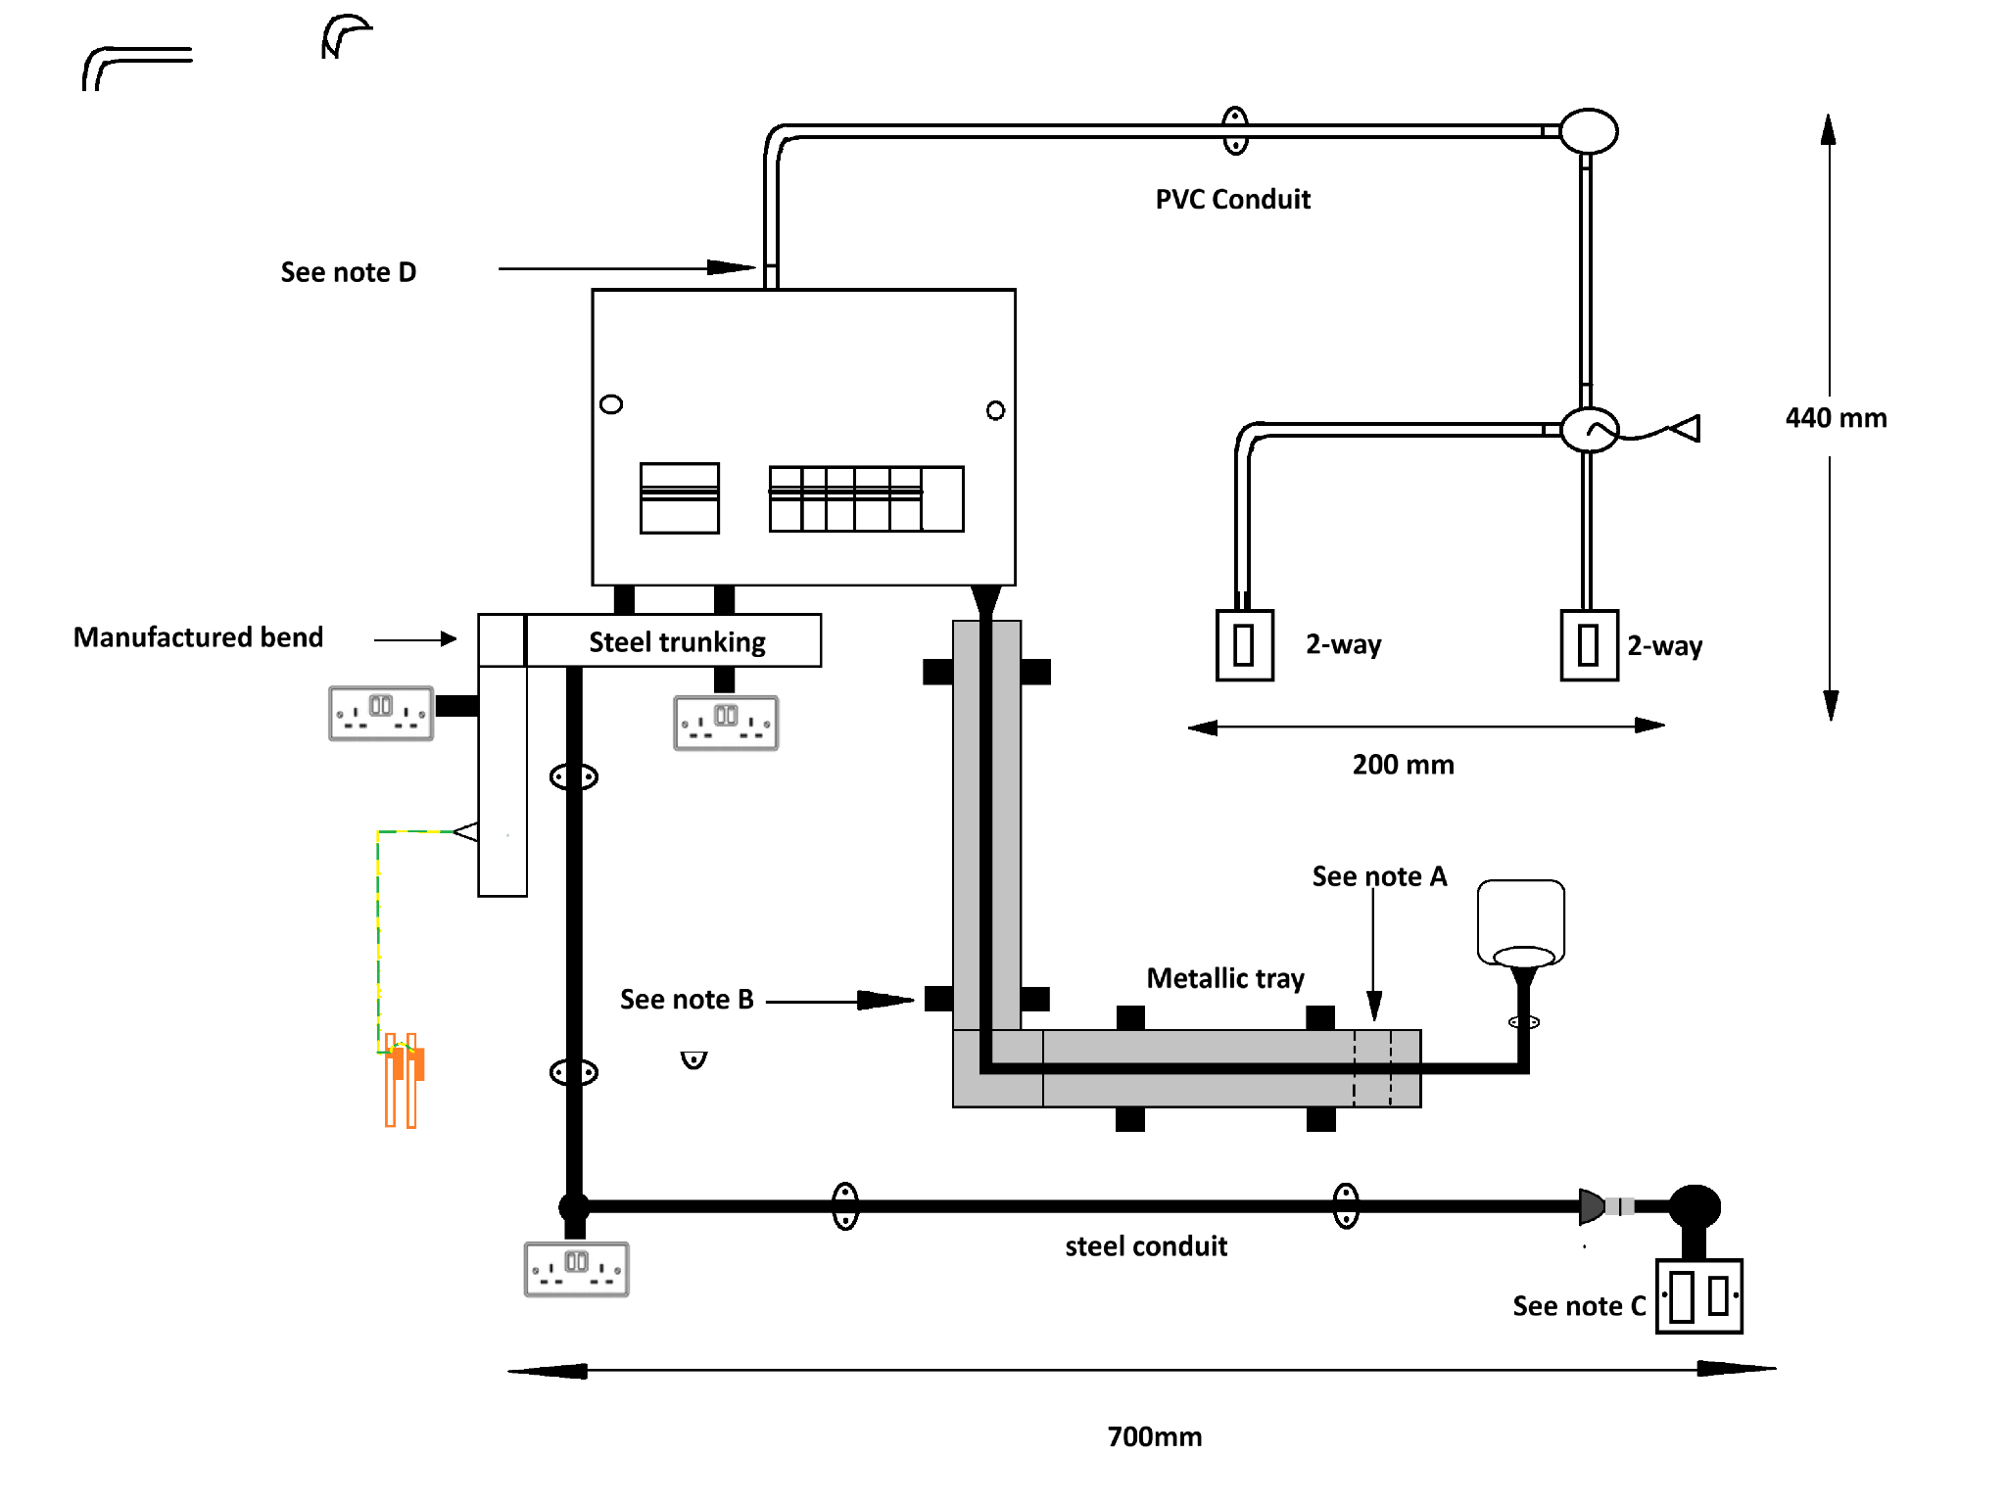

Light switch

The light circuit is on a 6 amp breaker.

Step One light
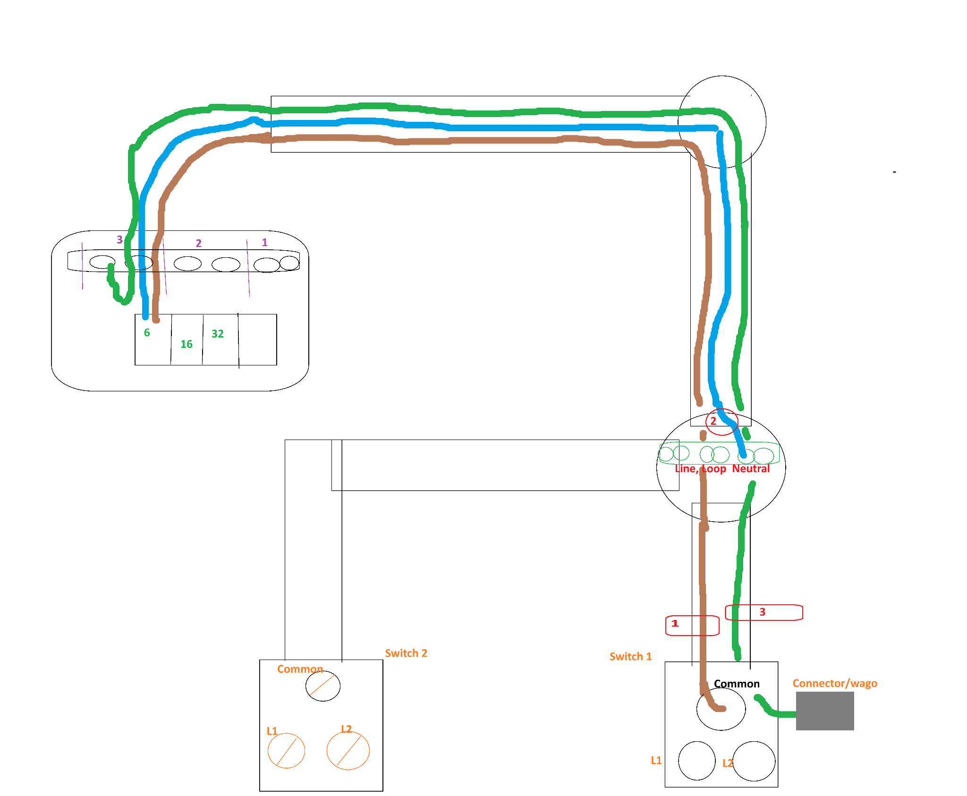

Step Two
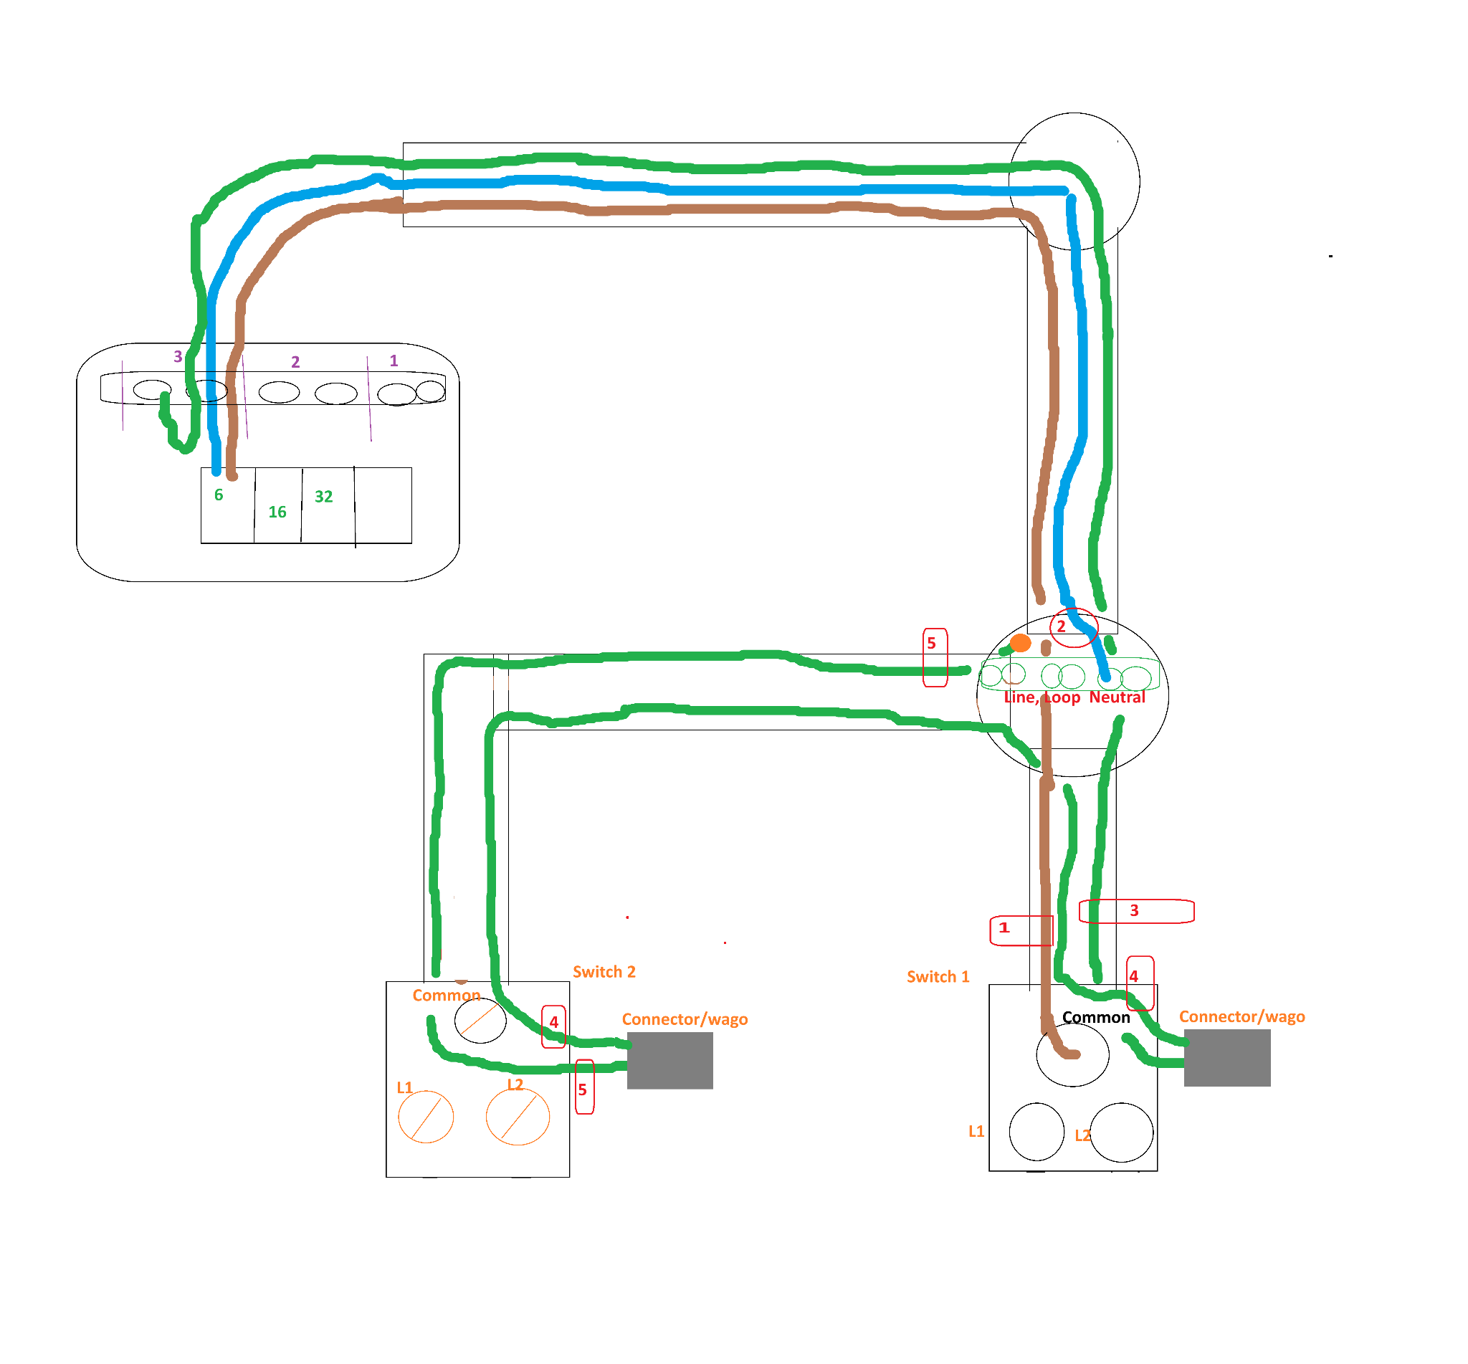

Step three - strappers
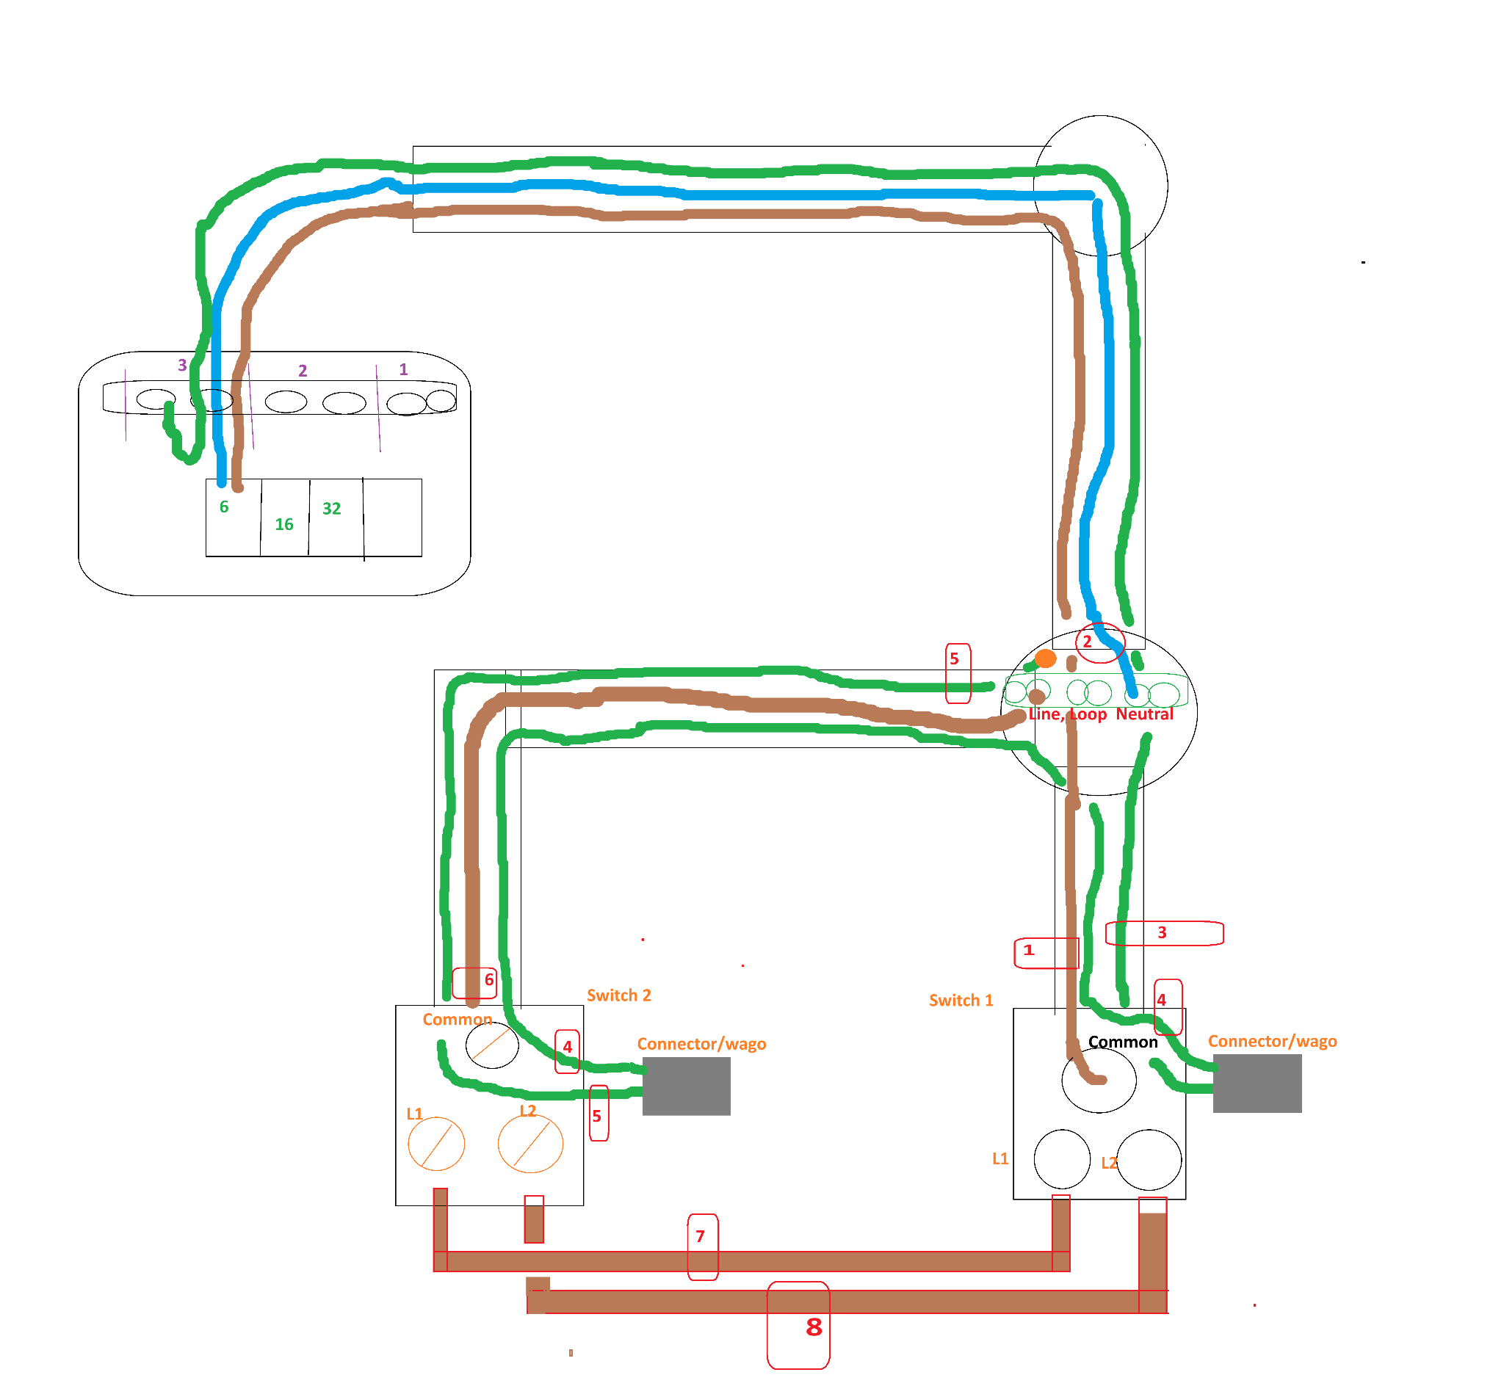

Step three - strappers

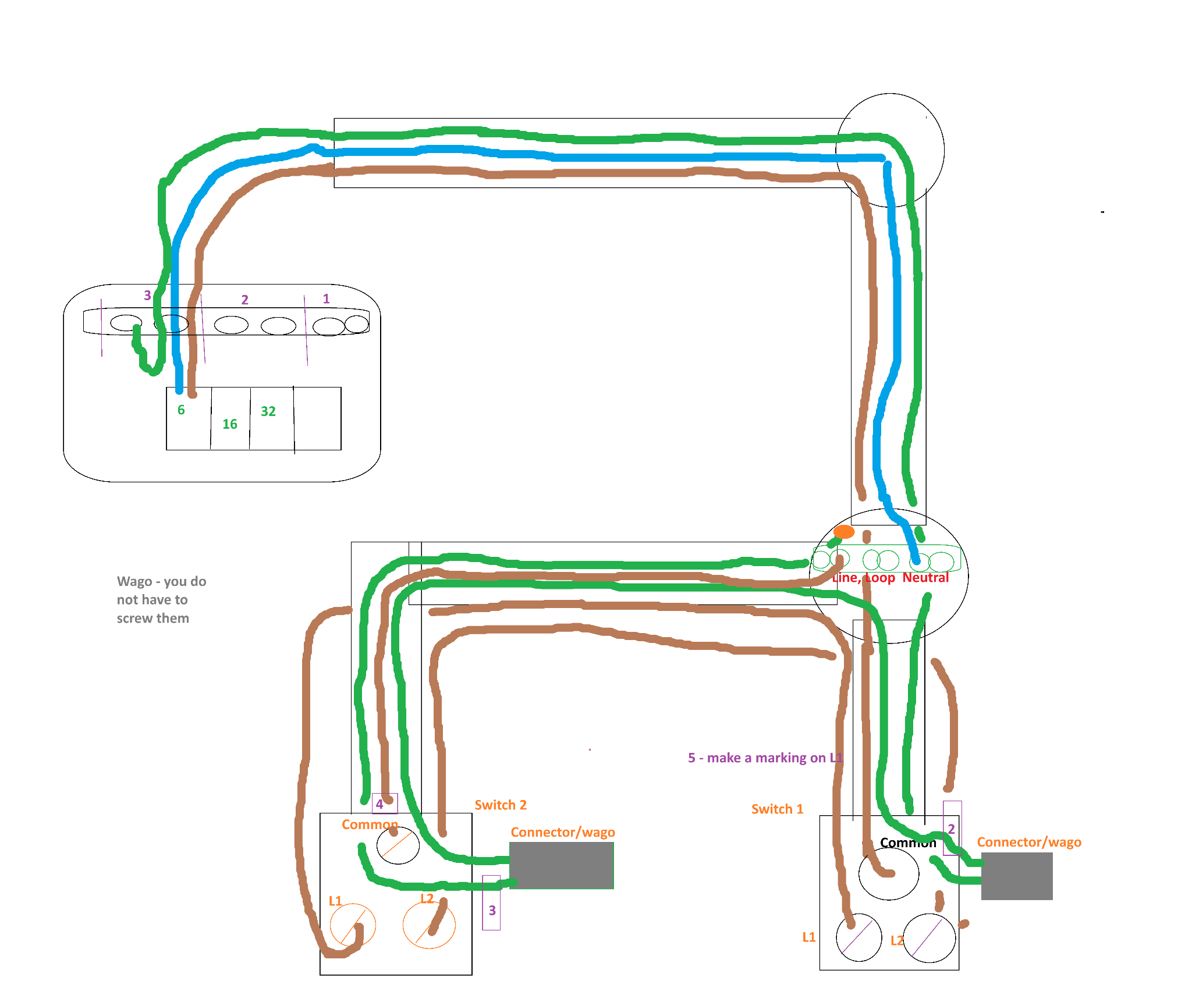

Steel conduit - Ring Circuit

Is on a 32 amp breaker.
The ring circuit as long as you have 2 blue 2 brown and 2 green at every point that means you will have the same at the fuse board both L and N both connected to the breaker and green to earth.
For the running coupler part. There are three things to consider.

First step

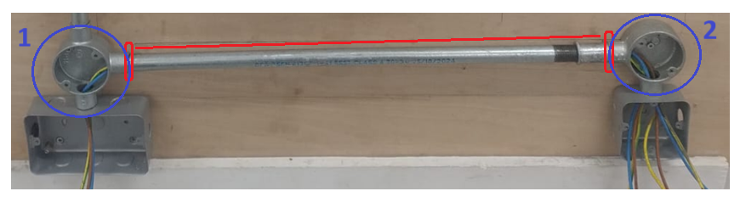

The first thing to do is to measure the length from the tip of the conduit angle box one to conduit angle box two. Indicated in red above.

Second step

For the conduit angle box two insert a nipple (which is a threaded coupler, where the threads are on the external). See the below makeshift image.

The length of the nipple is has to meet two criteria:
- First the nipple has to be long enough to screw all the way into the conduit angle box two;
- Secondly, the remainder that sticks out of conduit angle box two has to be equivalent to the length of half a coupler.
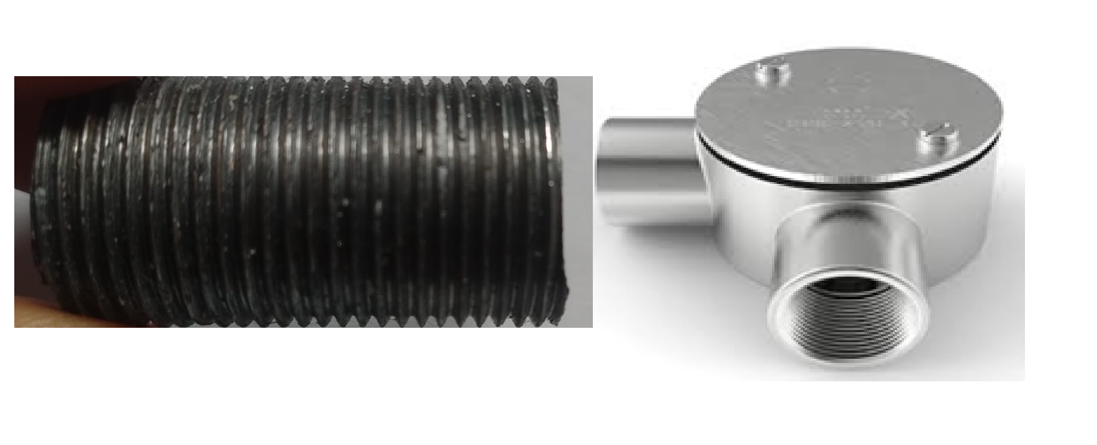

Third step

conduit angle box one side

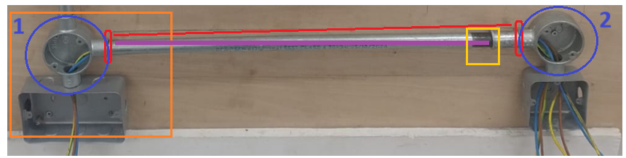

For the conduit angle box one the steel conduit already has a threaded end (on the side pointing into conduit angle box one). Therefore, I did not need to apply an external thread.

However, you may need to apply an external thread if not present. The amount of thread that you apply to the end should approximately be half a coupler length. Screw this side of the steel conduit into conduit angle box one.

Fourth step

conduit angle box two side

This will give you a small gap between the steel conduit and the nipple sticking out of conduit angle box two.

With the steel conduit on the opposite end. The end near to conduit angle box two. You need to apply sufficient external thread to the outside of the steel conduit. This will allow you to screw/run/move the lock ring and coupler from the end of the steel conduit onto the nipple. So that the end result is that both the end of the steel conduit and the nipple are underneath the lock ring and coupler.
The yellow section shows that you need to apply a thread to the end of the steel conduit to give you room to screw the coupler and lock ring onto the nipple.

SWA Radial Circuit
The SWA radial circuit is on a 16 amp breaker.

The swa brown, black and grey in the fuse board black is earth. Grey is n. Don’t forget sleeving. You will be fine.

Brown => Live
Black => yellow/green sleeving => earth
Grey=> Blue sleeve => Neutral

